An Introduction to reinforcement learning
Reinforcement Learnings
Reinforcement learning is learning what to do—how to map situations to actions—so
as to maximize a numerical reward signal.

Markov Decision Process
RL problems can be mathematically formulated as a finite Markov Decision Process(MDP). This is one approach to formulate a reinforcement learning problem.
Finite MDPs can be solved by multiple methods: dynamic programming, Monte Carlo method, Temporal difference methods.

- Agent: The learner and decision maker is called the agent.
Ex, a self-driving car, a house cleaning robot, etc.
- Environment: Everything outside the agent is called the environment. It is the surroundings the Agent interacts with.
Ex, road, warehouse, etc.
- State: state as a signal conveying to the agent some sense of “how the environment
is” at a particular time.
Ex, position/orientation of a robot, climate of a particular day, etc.
- Action: It is the decision the Agent takes at a particular time.
Ex, move forward, lift something, get back to the charging point, etc

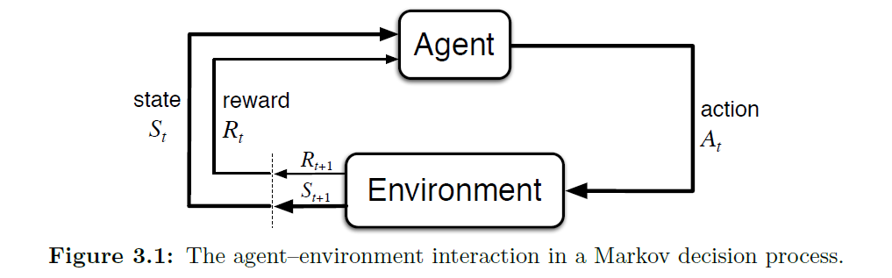

Reward (R_{t})
- The numerical signal that the agent receives from the environment at each time step is called the reward.
- Agent’s goal is to maximize the total amount of reward it receives. This means maximizing not immediate reward, but cumulative reward in the long run.
- We must provide rewards to it in such a way that in maximizing them the agent will achieve the final goal.

Return (G_{t})
It is the total reward that the Agent receives over a long run.
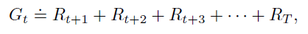

Discounting
The agent tries to select actions so that the sum of the discounted rewards it receives over the future is maximized. In particular, it chooses A_{t} to maximize the expected discounted return

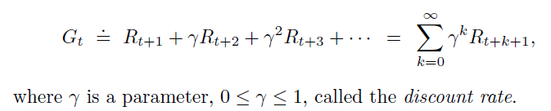

As 𝛾 approaches 1, the return objective takes future rewards into account more strongly; the agent becomes more farsighted.

Value functions
functions of states (or of state–action pairs) that estimate how good it is for the agent to be in a given state (or how good it is to perform a given action in a given state).
- State value functions
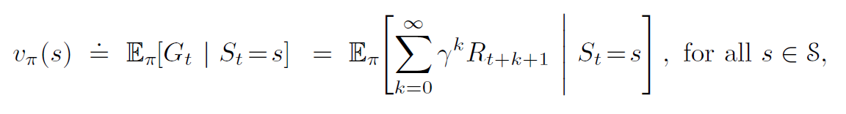
- Action value functions
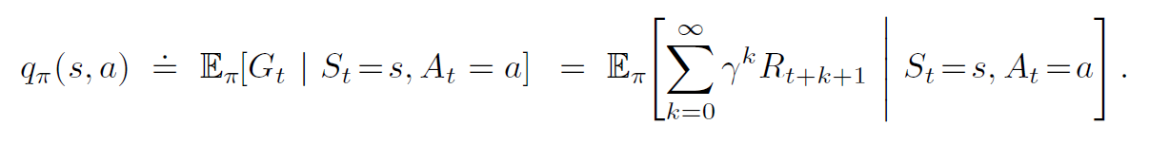
Policy
a policy is a mapping from states to probabilities of selecting each possible action.
If the agent is following policy $π$ at time t, then $π$(a|s) is the probability that A_{t} = a if S_{t} = s.

